SPACE4Cloud User Manual

V1.0.0.alpha

(https://github.com/deib-polimi/modaclouds-space4cloud/releases/tag/1.0.0.alpha)

Author:

Giovanni Paolo Gibilisco (giovannipaolo.gibilisco@polimi.it)

Index

Features 1

Requirements 1

Installation 2

Usage 4

# Features

System PerformAnce and Cost Evaluation on Cloud is a tool for the specification, assessment and optimisation of QoS characteristic of cloud applications. Models of the application, defined in Modelio and exported in the Palladio Component Model formalism with accompanying extensions, are evaluated in order to assess both performance and cost of the modelled solution. The tool is built on top of the Palladio Bench modelling environment but it differs significantly from Palladio since it enriches the modelling capabilities allowing more expressiveness in the definition of the resource environment and the specification of the workload. SPACE4Cloud implements state-of-the-art metaheuristic techniques to effectively and efficiently explore the space of possible alternative configurations. For each configuration involved in the search process, the tool is also capable of evaluating the overall operative cost. However, it makes use of tool LINE for the performance evaluation. More information on the tool can be found in deliverables D5.2.1[1] and D5.4.1[2] of the MODAClouds project.

# Requirements

In order to install and run the SPACE4Cloud tool the requirements listed in the table are needed:

|  |  |  |
| --- | --- | --- |
| Requirement | Version | Where to get it |
| Palladio-Bench 3.5 | 3.5 | <http://www.palladio-simulator.com/tools/download/> |
| Layered Queuing Network Solver (LQNS) | 4.5.7.2 | <http://www.sce.carleton.ca/rads/lqns/lqn-documentation/> |
| LINE | 0.5f | https://code.google.com/p/line/ |

SPACE4Cloud can use either LQNS or LINE as performance engines so at least one of the two has to be installed in the system.

# Installation

The installation of SPACE4Cloud over Palladio-Bench 3.5 is performed using the install new software feature of eclipse. It can be accessed as shown in Figure 1 by the menus:

*Help -> Install New Software..*

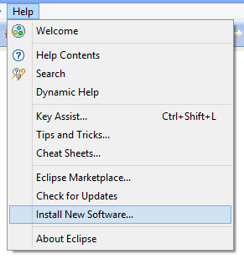

Figure

In the “Install” windows click the add a new update site by clicking the *Add* button as shown in Figure 2

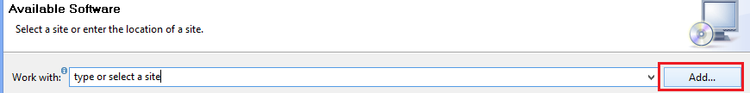

Figure

Insert the desired name (e.g. SPACE4Cloud) and use as location as shown in Figure 3:

<ftp://home.dei.polimi.it/outgoing/Giovanni.Paolo.Gibilisco/space4cloud/>

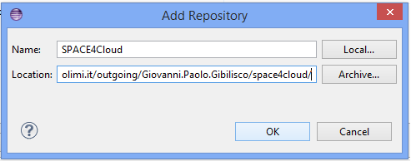

Figure

Back in the “*Install*” windows uncheck the “*Group Items by category*” option in order to show the available features, select both the *Space4Cloud* and *Palladio LINE Patch* features and click “*Next*”, as shown in Figure 4.

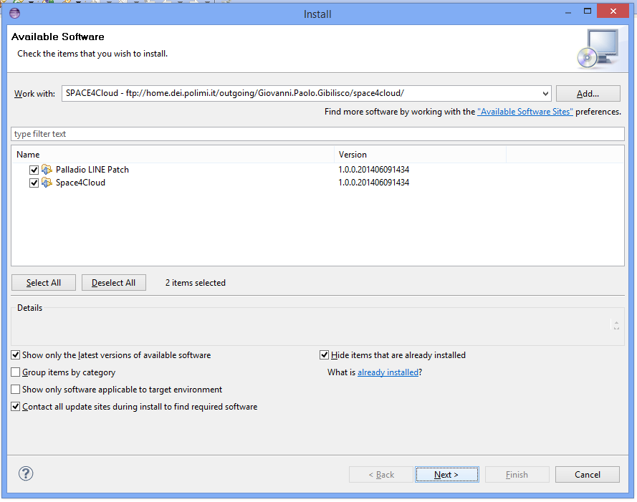

Figure

Eclipse will then compute the required actions in order to install patch the Palladio plugin that interacts with solution engines and install the SPACE4Cloud feature. This operation might take a while.

Eclipse will then ask you to confirm the removal of the old version of the Palladio plugin and the installation of the patched one as shown in Figure 5. Proceed by clicking “Next”, review the actions in the successive window then click “*Next”* again. Review the license and accept them in the last window.

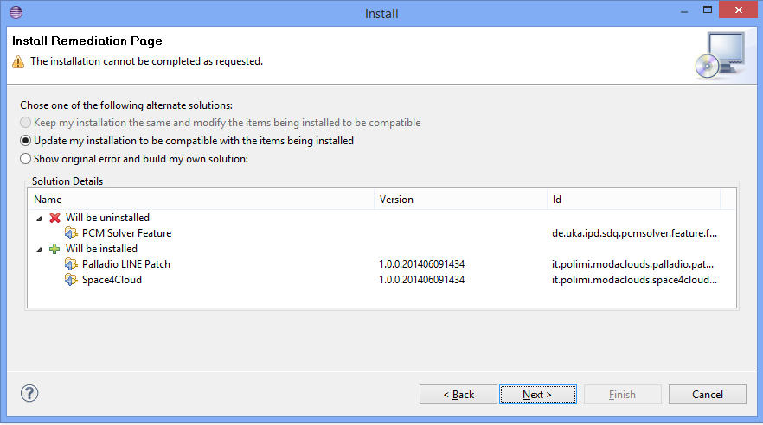

Figure

Eclipse will now perform the installation operations and warn the user that it is about to install unsigned content. Click “*OK*” on the warning and proceed with the installation. A restart of eclipse is suggested after the installation has been completed.

# Usage

The entry point to the SPACE4Cloud tool in the Palladio-Bench environment is the cloudy shaped icon that appears in the toolbar as shown in Figure 6.



Figure

Before starting the tool a project containing the required files has to be created or imported in the workspace. In order to do that the user can make a new project by using the “File->New->Project…” menu in eclipse and then selecting the template for a simple empty project as shown in Figure 7. Then import in the newly created project the needed files.

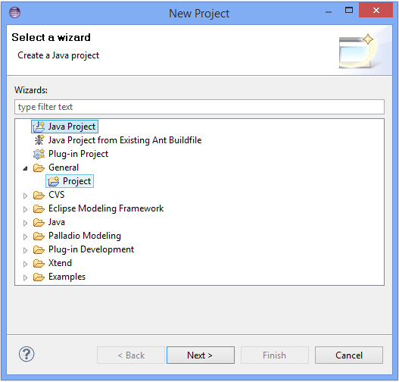

Figure

Another option is to download the sample project from <ftp://home.dei.polimi.it/outgoing/Giovanni.Paolo.Gibilisco/space4cloudExample> and import it using the “File->Import…” menu. Select the “*Existing Projects into Workspace*”, as shown in Figure 8, then select as root directory the downloaded one and click on “Finish”.



Figure

Either by copying the files or by importing the example the project should look like the one in Figure 9.

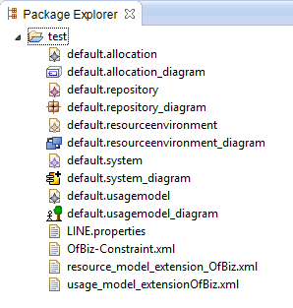

Figure

The following table briefly describe the files contained in the example project and their relation to SPACE4Cloud.

|  |  |
| --- | --- |
| File Name | Description |
| Default.allocation | Allocation model of PCM (**NEEDED**) |
| Default.allocation_diagram | Visual representation of the allocation model |
| Default.repository | Repository model of PCM (**NEEDED**) |
| Default.repository_diagram | Visual representation of the Repository model |
| Default.resourceenvironment | Resource Environment model of PCM (**NEEDED**) |
| Default.resourceenvironment_diagram | Visual representation of the resource environment model |
| Default.system | System model of PCM (**NEEDED**) |
| Default.system_diagram | Visual representation of the system model |
| Default.usagemodel | Usage model of PCM (**NEEDED**) |
| Default.usagemodel_diagram | Visual representation of the usage model |
| LINE.properties | Configuration file for the LINE performance evaluator (**NEEDED ONLY IF USING LINE**) |
| OfBiz-Constraint.xml | Extension file containing the constraints modeled by the user (**NEEDED**) |
| Resource_model_extension_OfBiz.xml | Extension file containing the mapping of PCM resource container to cloud resources (**NEEDED**) |
| Usage_model_extensionOfBiz.xml | Extension file containing the 24 hour profile of expected incoming workload (**NEEDED**) |

In order to run SPACE4Cloud click on the cloudy icon of Figure 6.

A pop up window will ask the user about the desired functionality, currently the supported functionalities are ***Assessment*** and ***Optimization***. The *Robustness* analysis is in an experimental feature that is still unstable.

Both Features will ask the user to load the necessary Palladio models (Figure 10), choose the desired solver (Figure 11), and load the *Usage Model*, *Resource Environment* and *Constraint* extensions (Figure 12).

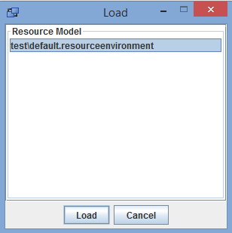

Figure

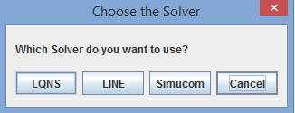

Figure

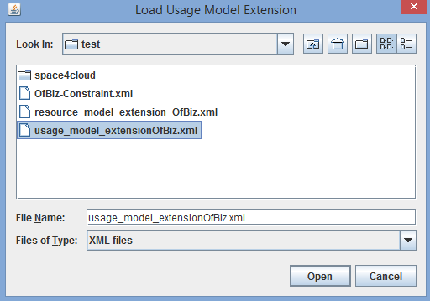

Figure

If the user choose to perform the assessment after a short while a windows with the information about the utilization and the response time of resources and functionalities modeled in the application will appear (Figure 14).

If the user selected the Optimization, a pop up will ask the user if he wants to automatically generate the initial solution, since this feature is still experimental we will click on “*No*” and let the tool proceed with the solution described in the extension files. Another Window will appear allowing the user to specify some parameters that are used by SPACE4Cloud to drive the optimization process, as shown in Figure 13. The max iterations and max feasibility iterations heavily affect the time taken in the optimization process as they are used to evaluate the convergence of the algorithm, the memory size is used to store candidate moves and can be increased if the type of available virtual machines is very big. For most of the considered provided the default value of 10 is sufficient. The selection policy define how the algorithm select resources that have to be scaled out when a solution does not meet user defined constraints. Experiments shows that the utilization policy is quite efficient in most situations, but if no constraints on the Utilization of components have been provided other policies can perform better.

Since the optimization can take from few minutes to hours, according to the complexity of the application and the specified parameters, a window will show its progress.

The window show in Figure 15 is divided into three sub figures.

The leftmost shows for each tier the amount of virtual machines used by the candidate solutions. The number on the y axis refer to the sum of all the machines used during the 24 hours. The central image shows the cost of the candidate (in red) and of the best solution found by the algorithm (in blue) per day in dollars. The rightmost window shows the number of constraints that are violated by the candidate solution.

When the optimization process has finished an xml representation of the optimized solution can be found in the *space4cloud* folder of the project in the file *solution.xml*

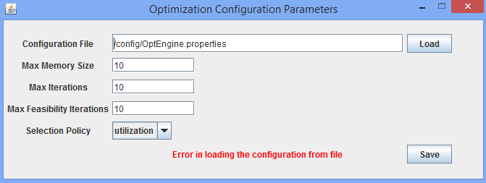

Figure

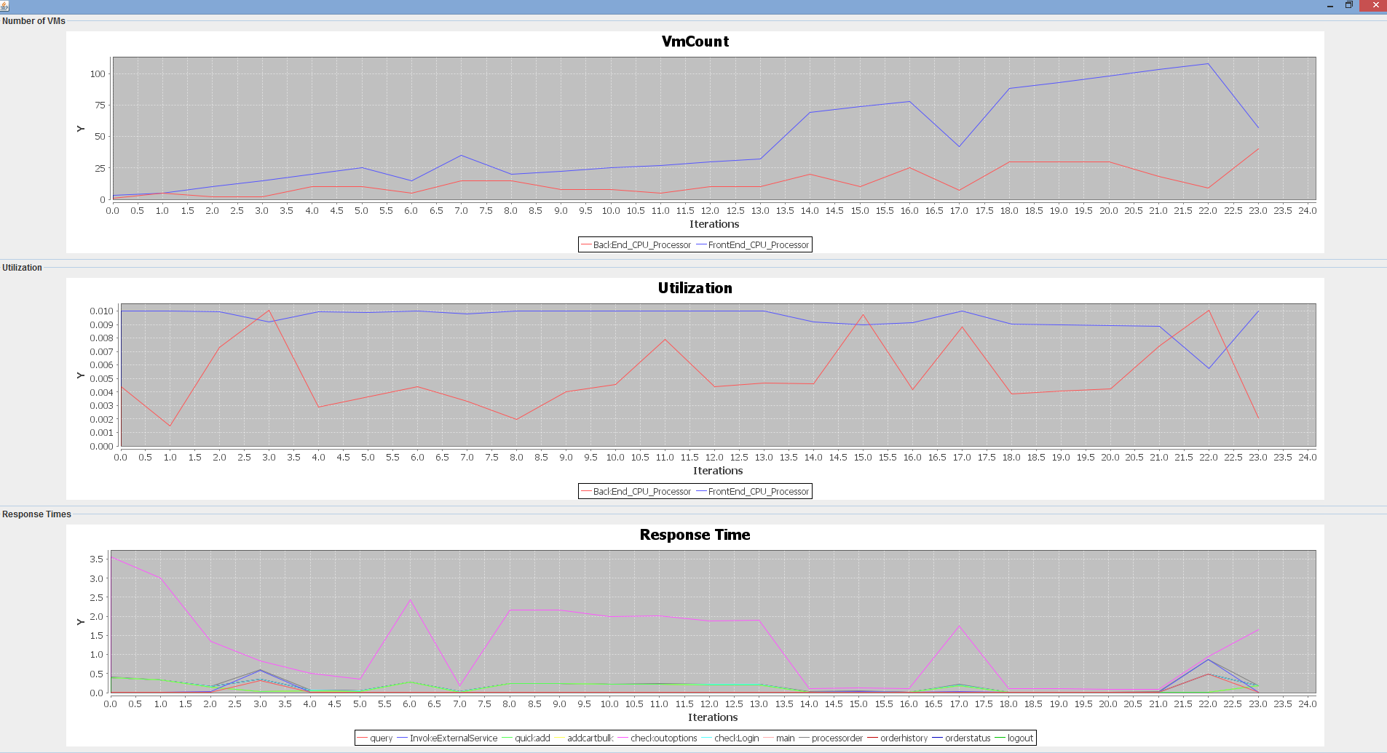

Figure

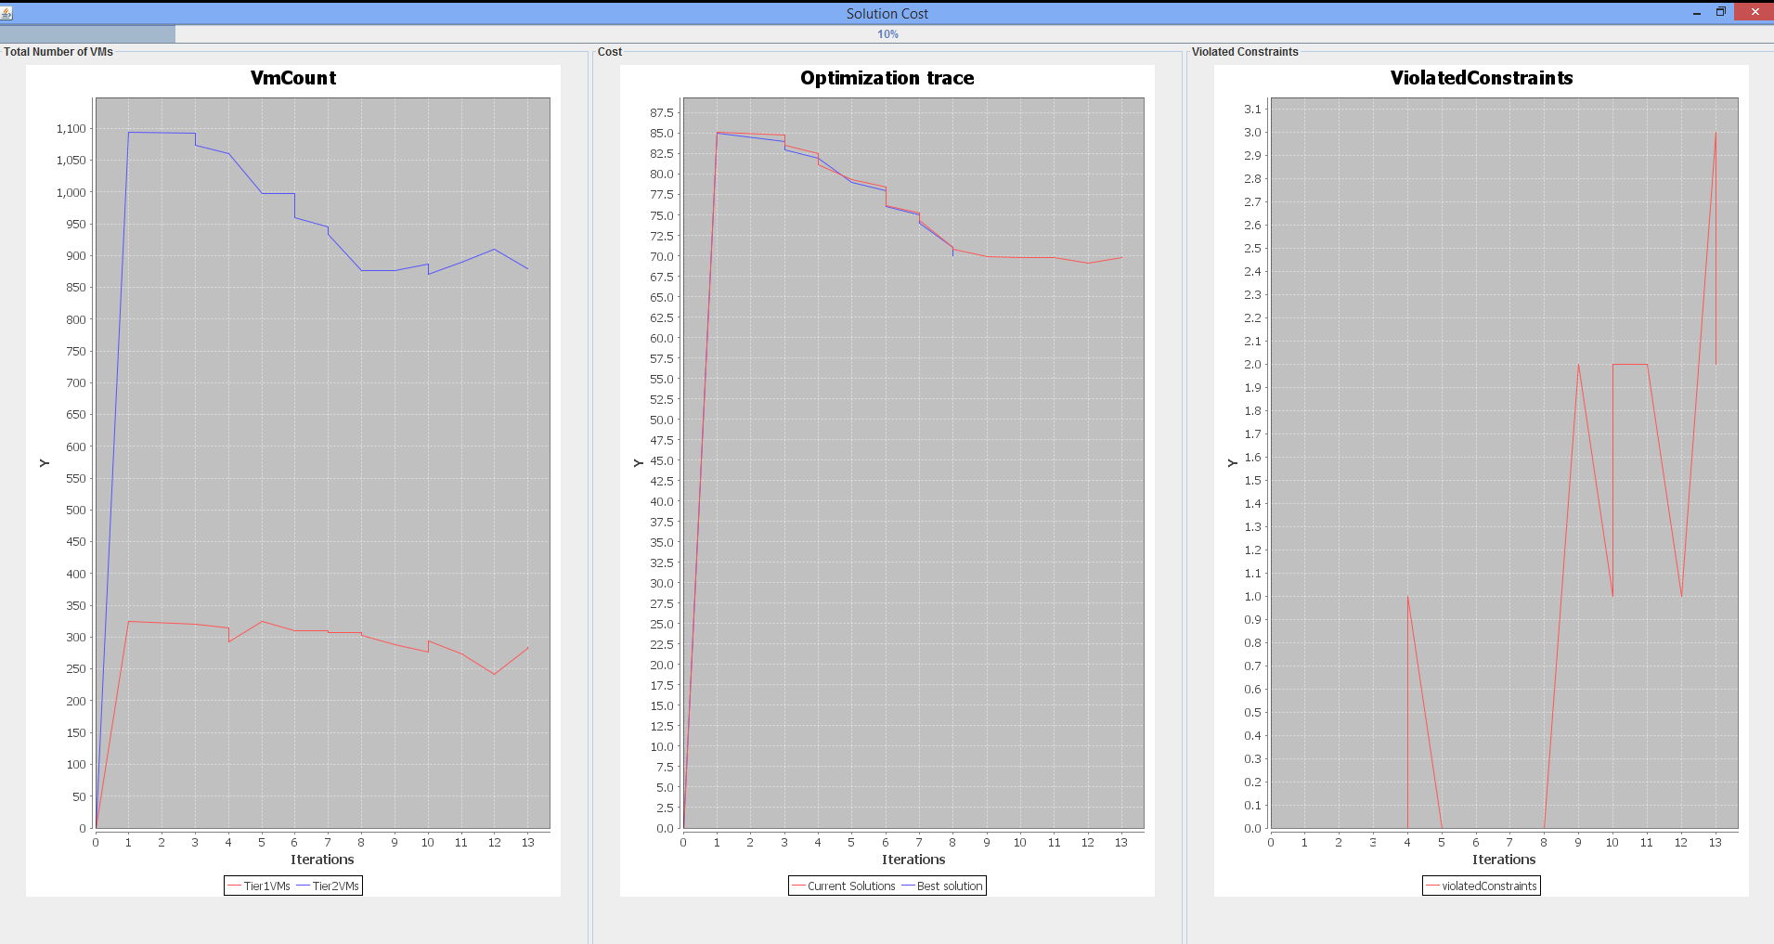

Figure

1. <http://www.modaclouds.eu/wp-content/uploads/2012/09/MODAClouds_D5.2.1_MODACloudMLQoSAbstractionsAndPredictionModelsSpecificationInitialVersion.pdf>
2. <http://www.modaclouds.eu/wp-content/uploads/2012/09/MODAClouds_D5.4.1_PredictionAndCostAssessmentToolProofOfConcept.pdf>